Interactive Chatbot with Learning Capabilities

- Description

The project aims to develop an interactive chatbot that can accurately respond to user queries. The chatbot will be able to learn new information from users and use the OpenAI API to find answers to questions it doesn’t know. The chatbot will also have speech capabilities, allowing it to communicate with users verbally.

- Overview
The code snippet is for a chatbot-like program that can interact with users via text or voice, convert text to speech (TTS), and recognize speech (speech-to-text or STT). It also uses users and OpenAI's API to get responses and has a knowledge base to store questions and answers.
The chatbot is a console-based application. It interact with users through a simple text interface where users can type their questions. The chatbot will then respond to these questions either by providing an answer it already knows, learning a new answer from the user, or using the OpenAI API to find an answer.

The user can interact with the chatbot in the following ways:

- Ask a question: The user types a question, and the chatbot responds with an answer if it knows one.
- Teach the chatbot: If the chatbot doesn’t know the answer to a question, it will ask the user to teach it. The user can then input an answer, which the chatbot will remember for future questions.
- Use OpenAI API: If the user doesn’t know the answer to a question, the chatbot will use the OpenAI API to find an answer.
The chatbot will be designed to handle a wide range of questions, making it a versatile tool for information retrieval. It will be able to handle questions about various topics, including general knowledge, trivia, and specific areas of interest.

- Major Blocks of the Code
- Imports
The code imports various libraries for asynchronous processing, JSON data handling, speech recognition, text-to-speech, AI interactions, and concurrency.
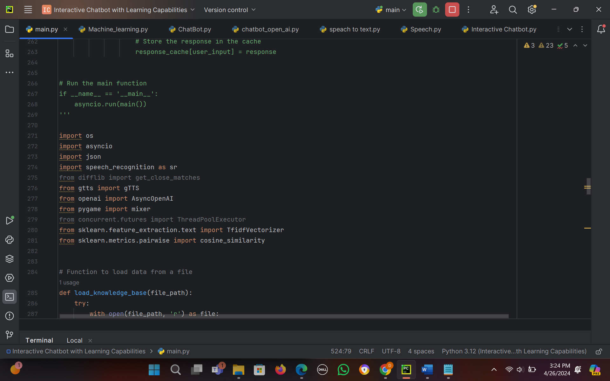
- Knowledge Base Handling
Load Data: The load_knowledge_base function loads a JSON file to create a knowledge base where questions and answers are stored.
Save Data: The save_knowledge_base function saves data to a specified file, updating the knowledge base with new questions and answers.
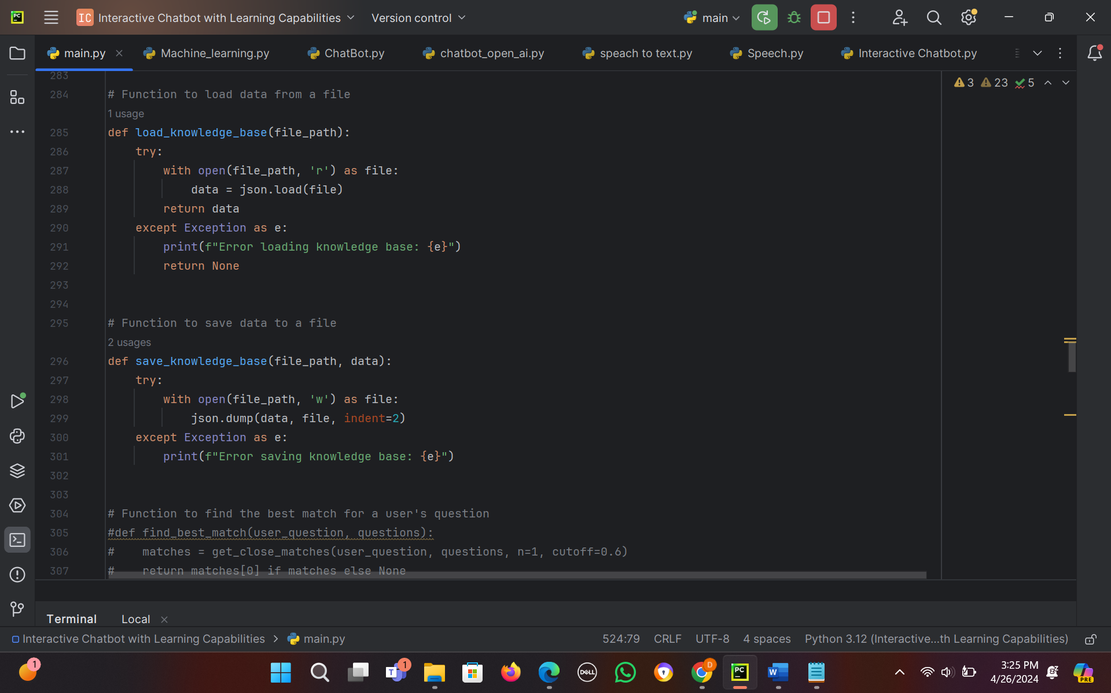
- Question Matching
Text Matching: find_best_match uses a TF-IDF vectorizer and cosine similarity to find the best matching question from a given list.
Answer Retrieval: get_answer_for_question retrieves the answer to a question from the knowledge base.
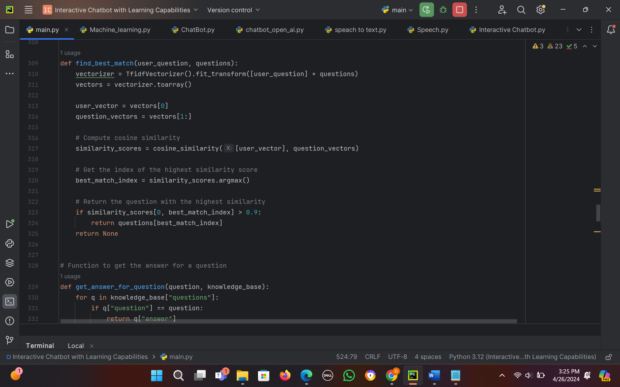
- Text-to-Speech and Speech-to-Text
Text-to-Speech (TTS): text_to_speech converts text into audio using Google Text-to-Speech and plays it using pygame's mixer.
Speech-to-Text (STT): speech_to_text captures audio through a microphone and converts it to text using Google's speech recognition.
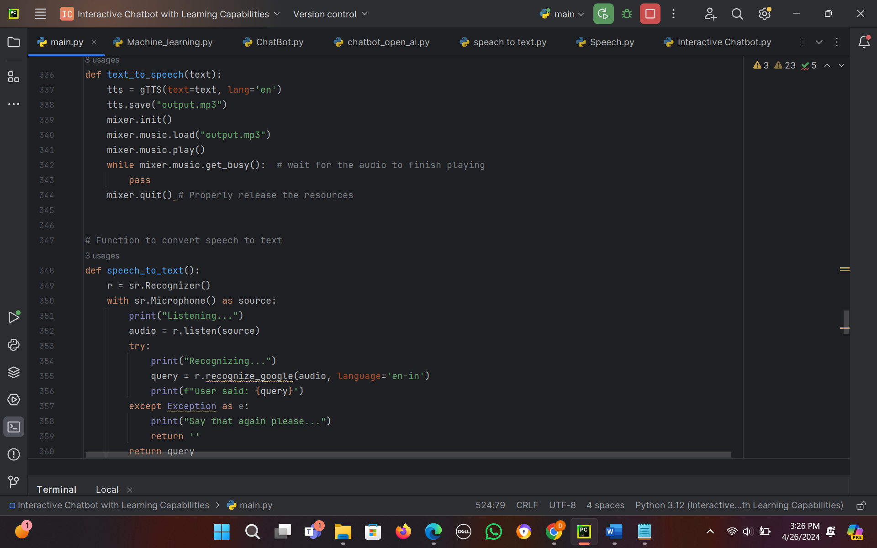
- OpenAI Interaction
API Call Limit: The code has a limit of two OpenAI API calls per session. get_response_from_openai makes asynchronous calls to OpenAI's GPT-3.5-turbo model to get responses to user queries.
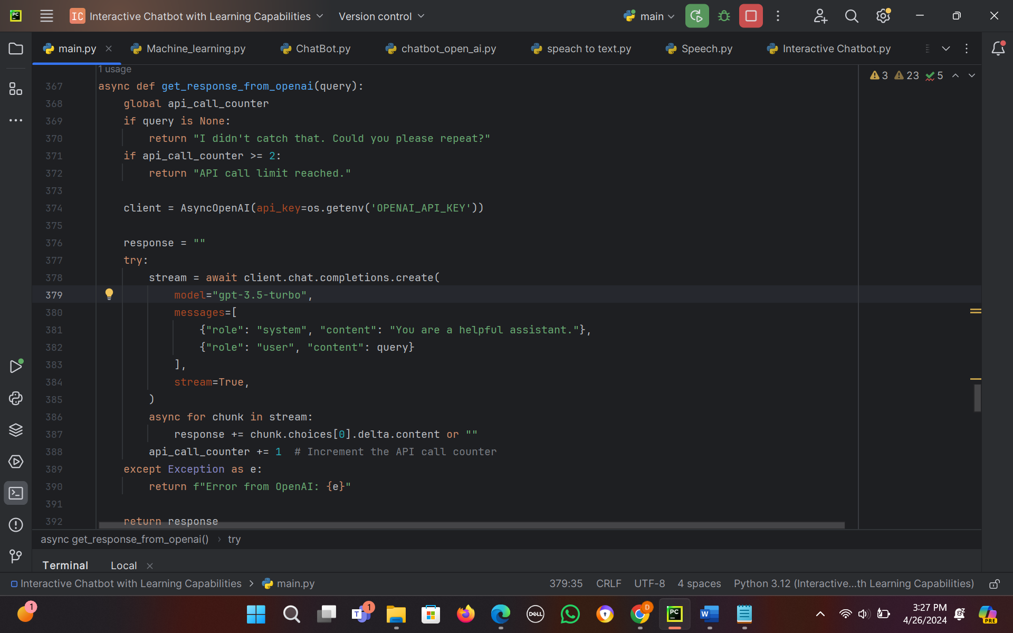
- Main Function
The main function sets up the chatbot's interaction mode (text or voice) and continuously listens for user input.
If the input matches a known question, it retrieves the answer from the knowledge base.
If it doesn't, it requests a new answer from OpenAI or from the user, updating the knowledge base with the new information.
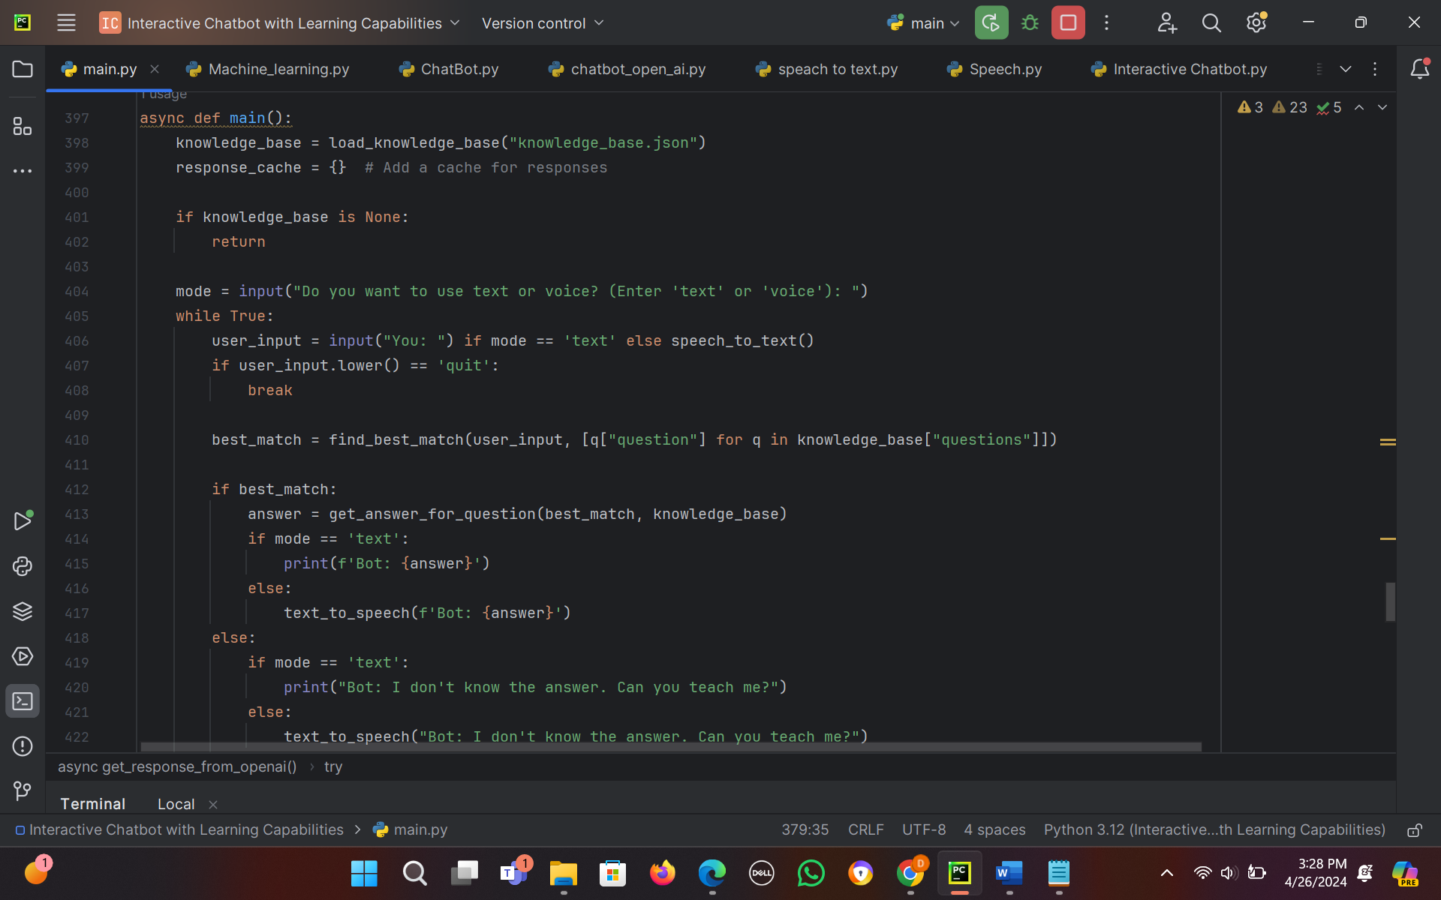
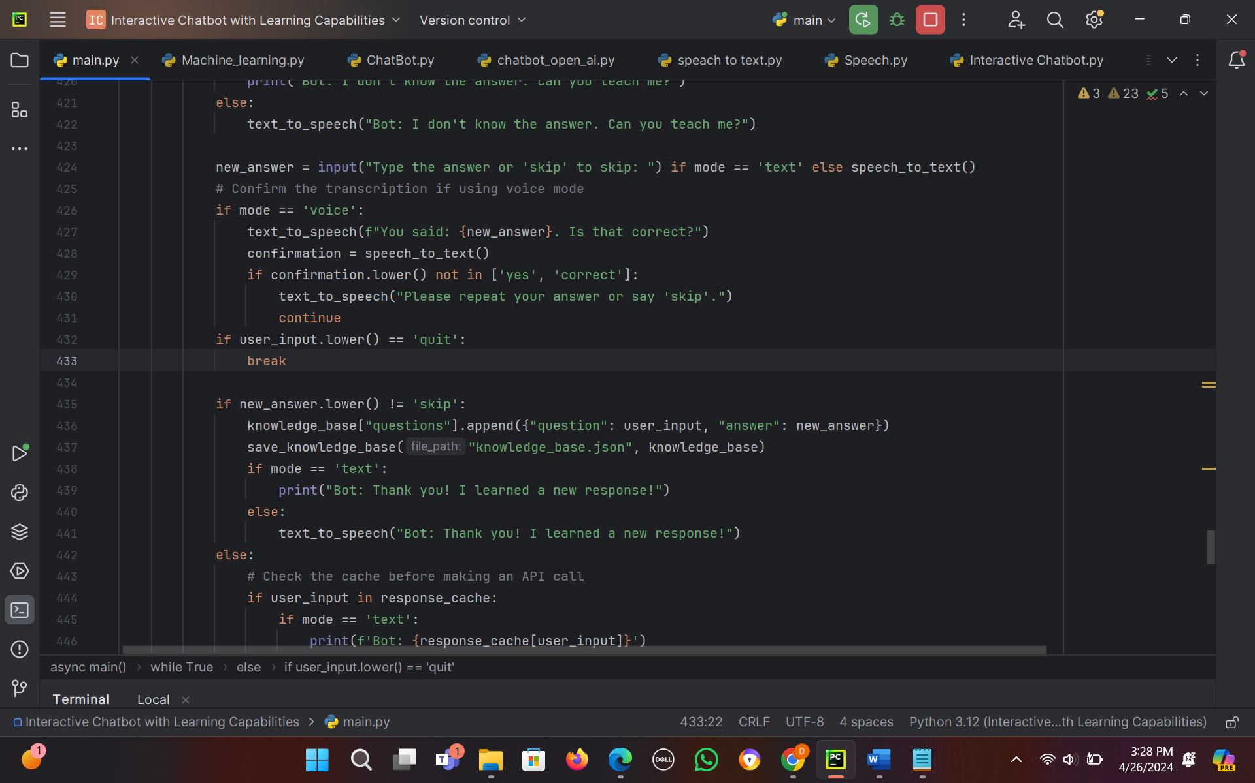
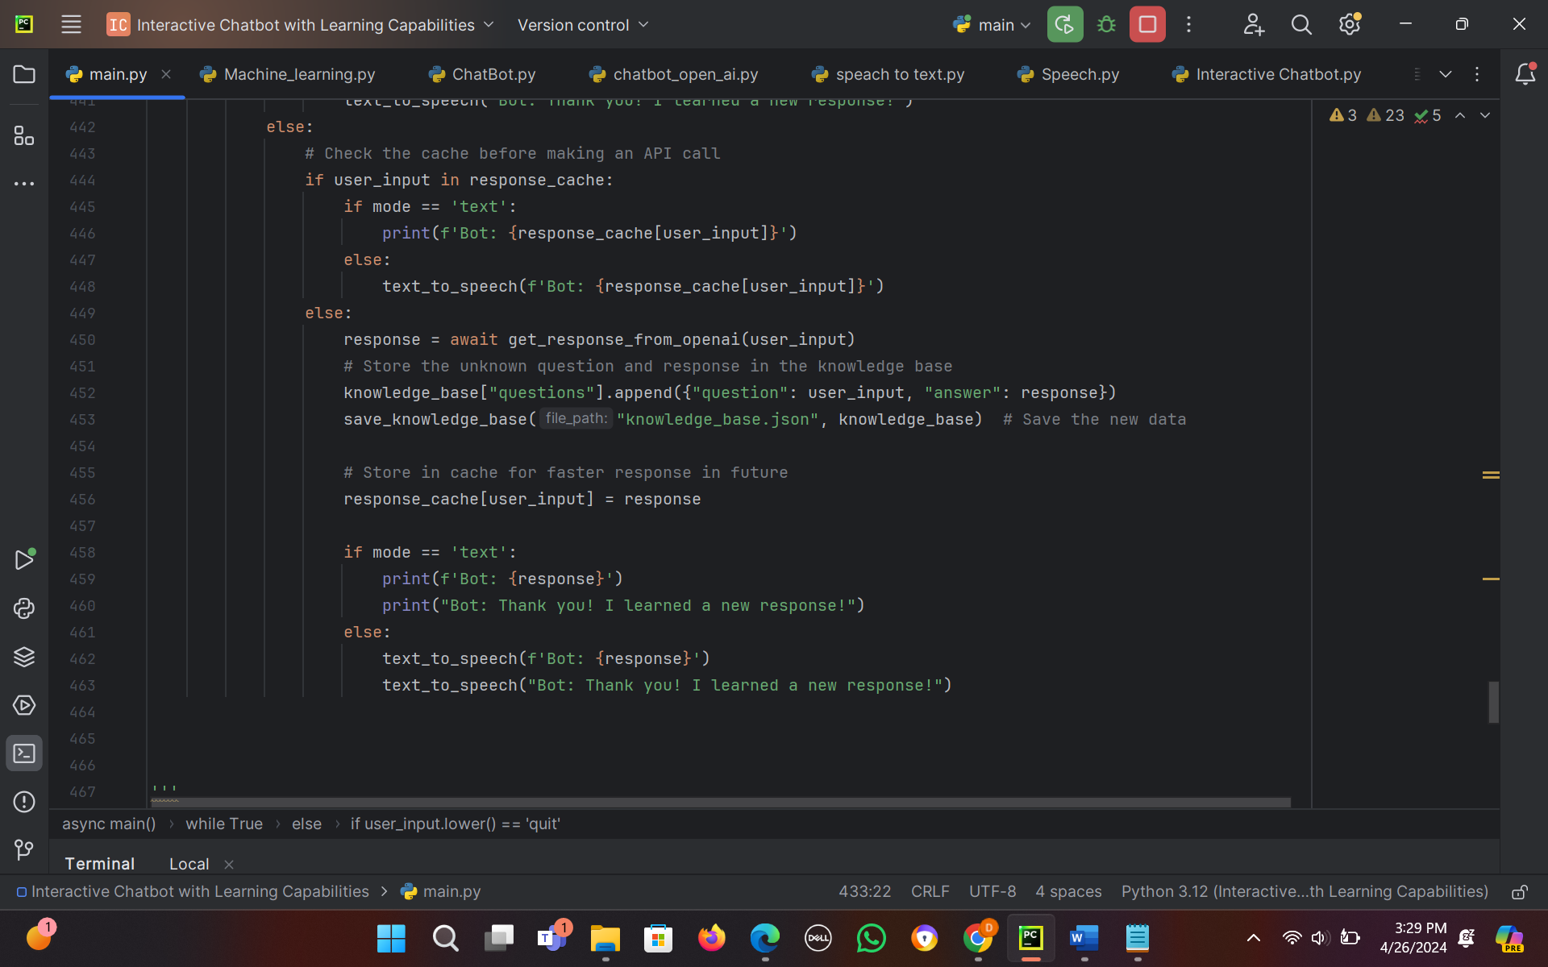

Screenshots and Results:
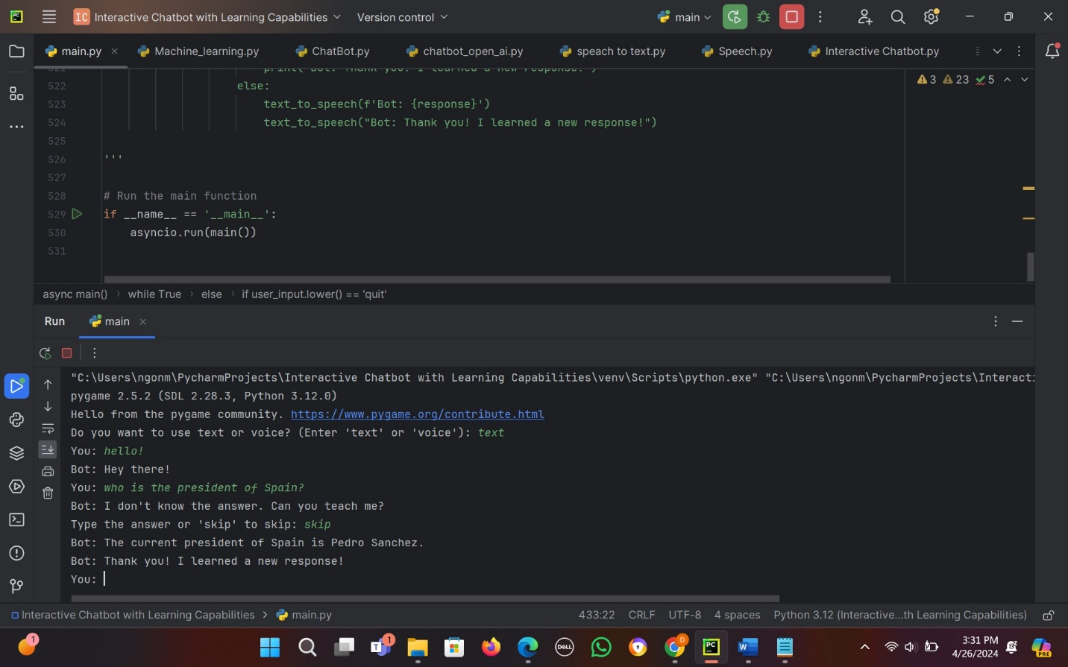
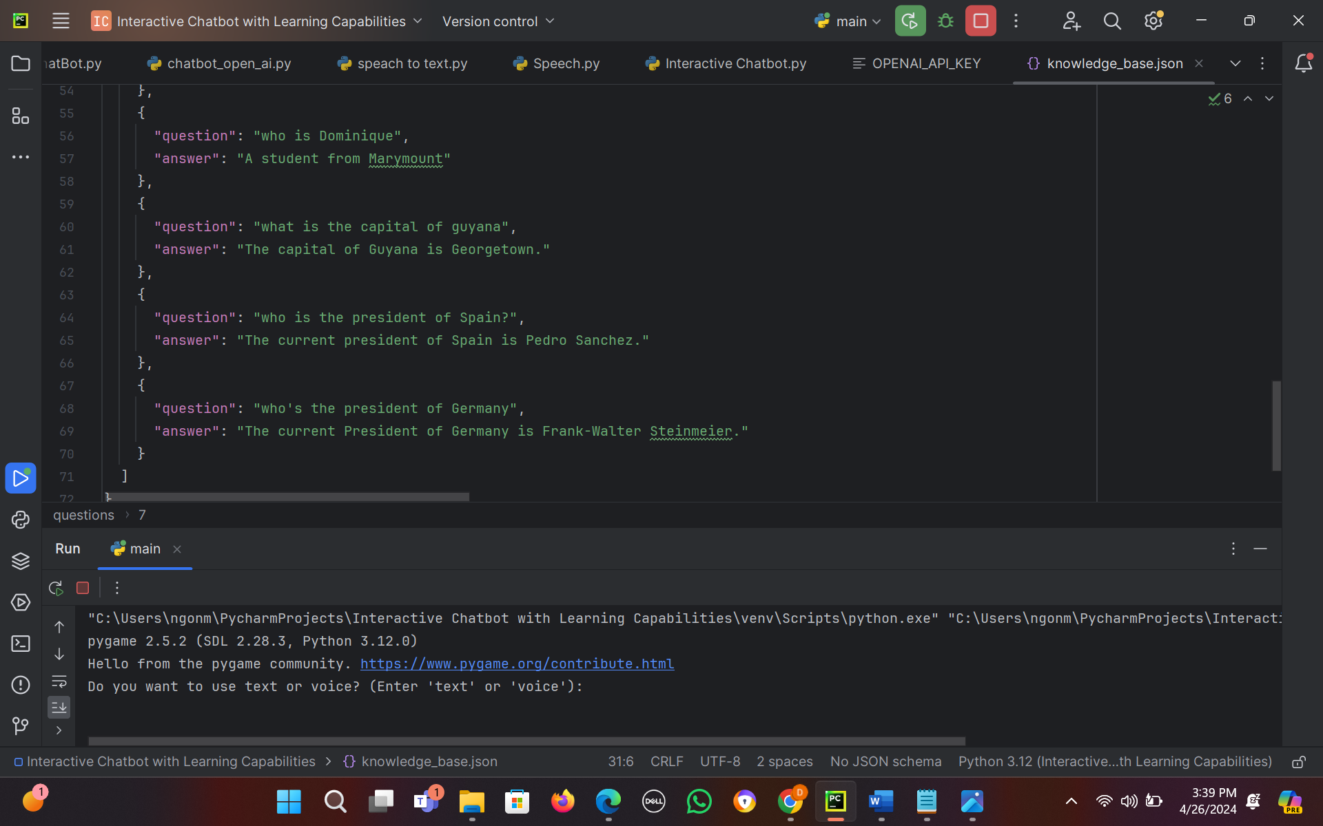

- Challenges and Solutions
One of the main challenges of this project was handling the interaction with the OpenAI API. Using the API requires proper authentication and handling, and there are costs associated with its usage. To solve this, the project include error handling for API requests and manage its usage according to OpenAI’s usage policies.

Another challenge is ensuring that the chatbot learns new information effectively. The chatbot is able to remember new Q&A pairs and use them to answer future questions. This is achieved by saving the new Q&A pairs to a JSON file.

Additionally, the project needed to handle various types of user input. Users may ask questions in different ways, and the chatbot will need to be able to understand and respond to these variations. This will be addressed by designing the chatbot to be flexible and adaptable in its responses.

Finally, the project needed to ensure that the chatbot’s speech capabilities are clear and understandable. This involve using gtts, feature_extraction, metrics, etc.. library’s settings to produce high-quality speech.
Code:
import os
import asyncio
import json
import speech_recognition as sr
from difflib import get_close_matches
from gtts import gTTS
from openai import AsyncOpenAI
from pygame import mixer
from concurrent.futures import ThreadPoolExecutor
from sklearn.feature_extraction.text import TfidfVectorizer
from sklearn.metrics.pairwise import cosine_similarity
# Function to load data from a file
def load_knowledge_base(file_path):
try:
with open(file_path, 'r') as file:
data = json.load(file)
return data
except Exception as e:
print(f"Error loading knowledge base: {e}")
return None
# Function to save data to a file
def save_knowledge_base(file_path, data):
try:
with open(file_path, 'w') as file:
json.dump(data, file, indent=2)
except Exception as e:
print(f"Error saving knowledge base: {e}")
# Function to find the best match for a user's question
#def find_best_match(user_question, questions):
# matches = get_close_matches(user_question, questions, n=1, cutoff=0.6)
# return matches[0] if matches else None
def find_best_match(user_question, questions):
vectorizer = TfidfVectorizer().fit_transform([user_question] + questions)
vectors = vectorizer.toarray()
user_vector = vectors[0]
question_vectors = vectors[1:]
# Compute cosine similarity
similarity_scores = cosine_similarity([user_vector], question_vectors)
# Get the index of the highest similarity score
best_match_index = similarity_scores.argmax()
# Return the question with the highest similarity
if similarity_scores[0, best_match_index] > 0.9:
return questions[best_match_index]
return None
# Function to get the answer for a question
def get_answer_for_question(question, knowledge_base):
for q in knowledge_base["questions"]:
if q["question"] == question:
return q["answer"]
# Function to convert text to speech
def text_to_speech(text):
tts = gTTS(text=text, lang='en')
tts.save("output.mp3")
mixer.init()
mixer.music.load("output.mp3")
mixer.music.play()
while mixer.music.get_busy(): # wait for the audio to finish playing
pass
mixer.quit() # Properly release the resources
# Function to convert speech to text
def speech_to_text():
r = sr.Recognizer()
with sr.Microphone() as source:
print("Listening...")
audio = r.listen(source)
try:
print("Recognizing...")
query = r.recognize_google(audio, language='en-in')
print(f"User said: {query}")
except Exception as e:
print("Say that again please...")
return ''
return query
# Function to get response from OpenAI (limit to 2 calls)
api_call_counter = 0 # Initialize a counter for API calls
async def get_response_from_openai(query):
global api_call_counter
if query is None:
return "I didn't catch that. Could you please repeat?"
if api_call_counter >= 2:
return "API call limit reached."
client = AsyncOpenAI(api_key=os.getenv('OPENAI_API_KEY'))
response = ""
try:
stream = await client.chat.completions.create(
model="gpt-3.5-turbo",
messages=[
{"role": "system", "content": "You are a helpful assistant."},
{"role": "user", "content": query}
],
stream=True,
)
async for chunk in stream:
response += chunk.choices[0].delta.content or ""
api_call_counter += 1 # Increment the API call counter
except Exception as e:
return f"Error from OpenAI: {e}"
return response
#'''
# Main function
async def main():
knowledge_base = load_knowledge_base("knowledge_base.json")
response_cache = {} # Add a cache for responses
if knowledge_base is None:
return
mode = input("Do you want to use text or voice? (Enter 'text' or 'voice'): ")
while True:
user_input = input("You: ") if mode == 'text' else speech_to_text()
if user_input.lower() == 'quit':
break
best_match = find_best_match(user_input, [q["question"] for q in knowledge_base["questions"]])
if best_match:
answer = get_answer_for_question(best_match, knowledge_base)
if mode == 'text':
print(f'Bot: {answer}')
else:
text_to_speech(f'Bot: {answer}')
else:
if mode == 'text':
print("Bot: I don't know the answer. Can you teach me?")
else:
text_to_speech("Bot: I don't know the answer. Can you teach me?")
new_answer = input("Type the answer or 'skip' to skip: ") if mode == 'text' else speech_to_text()
# Confirm the transcription if using voice mode
if mode == 'voice':
text_to_speech(f"You said: {new_answer}. Is that correct?")
confirmation = speech_to_text()
if confirmation.lower() not in ['yes', 'correct']:
text_to_speech("Please repeat your answer or say 'skip'.")
continue
if user_input.lower() == 'quit':
break
if new_answer.lower() != 'skip':
knowledge_base["questions"].append({"question": user_input, "answer": new_answer})
save_knowledge_base("knowledge_base.json", knowledge_base)
if mode == 'text':
print("Bot: Thank you! I learned a new response!")
else:
text_to_speech("Bot: Thank you! I learned a new response!")
else:
# Check the cache before making an API call
if user_input in response_cache:
if mode == 'text':
print(f'Bot: {response_cache[user_input]}')
else:
text_to_speech(f'Bot: {response_cache[user_input]}')
else:
response = await get_response_from_openai(user_input)
# Store the unknown question and response in the knowledge base
knowledge_base["questions"].append({"question": user_input, "answer": response})
save_knowledge_base("knowledge_base.json", knowledge_base) # Save the new data
# Store in cache for faster response in future
response_cache[user_input] = response
if mode == 'text':
print(f'Bot: {response}')
print("Bot: Thank you! I learned a new response!")
else:
text_to_speech(f'Bot: {response}')
text_to_speech("Bot: Thank you! I learned a new response!")
# Run the main function
if __name__ == '__main__':
asyncio.run(main())

